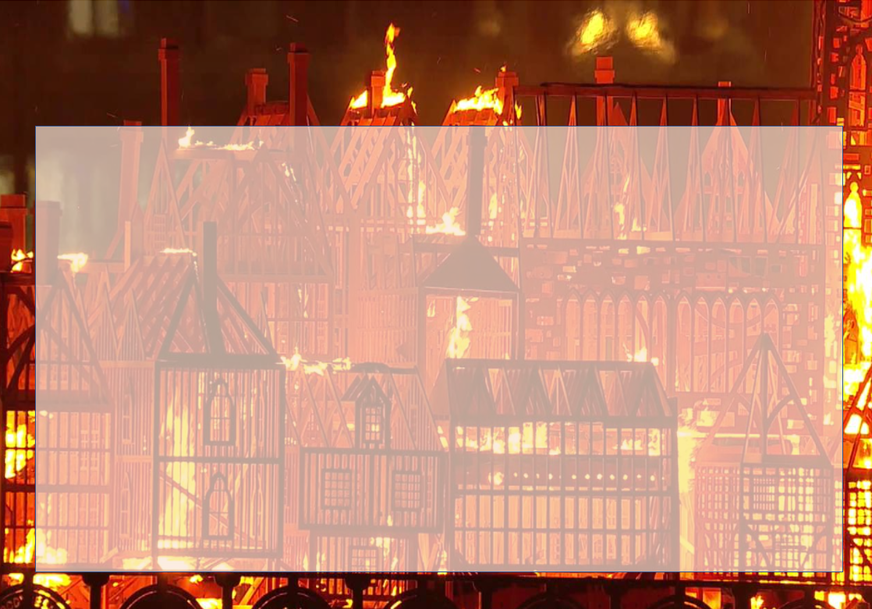
Year 2- London’s Calling- Holiday Homework Activities
Here are some optional homework activities to give you a head start on your learning. Bring the finished product in or share some photos with us. Merits will be awarded to all students who put effort into their project.

Go on a trip to London, visit all of the main landmarks. Create a video diary, draw pictures or take photos and put them all together as a collage of your trip.  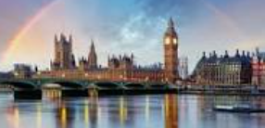 | Write a story, diary entry or poem about the Great Fire of London or one set in modern-day London.  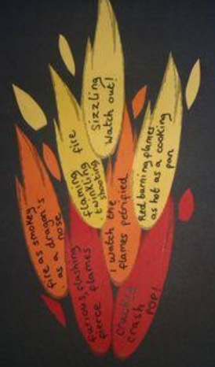 | Learn the song London’s Burning and add your own actions. Be ready to perform it to the class. | Make a model of a Tudor house using recycled materials.  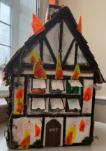
Design an information poster to promote fire safety. Create a catchy slogan or advert to help people remember what to do in a fire.  Research the job of a firefighter and present your findings in any way you want to. | Create or reproduce a picture depicting a scene from London during the great fire. Use any materials you have at home.  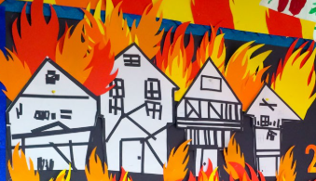 | 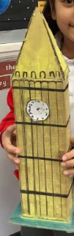  Make a model of a modern-day London landmark. Use materials you have at home. | Or any other project idea you have relating to the Great Fire of London or modern-day London.

