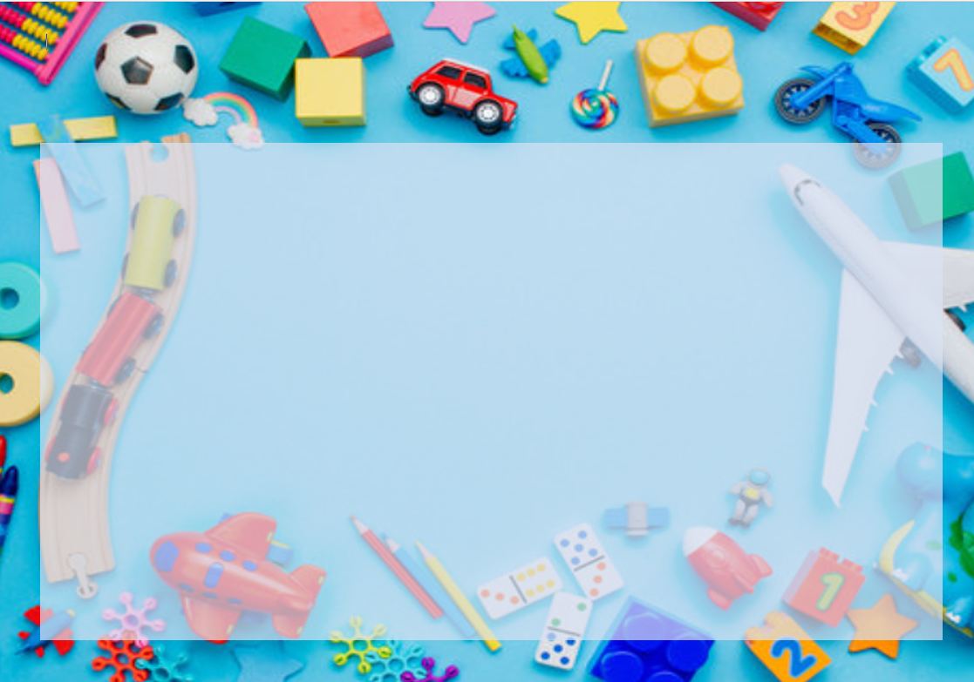
Year 1- A Trip Down Memory Lane- Holiday Homework Activities
Here are some optional homework activities to give you a head start on your learning. Bring the finished product in or share some photos with us. Merits will be awarded to all students who put effort into their project.

Design your own toy or make up your own game. Write down the rules, bring it in to school and teach everyone how to play with it.  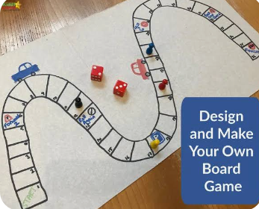 | Draw a picture of your favourite toy. Tell us about it and write down why you love it so much.   | Write a story about your favourite toy coming to life. Use Toy Story for inspiration. What do your toys do when you are at school?   | Find a local toy museum online and visit it. Draw pictures of what you see there.  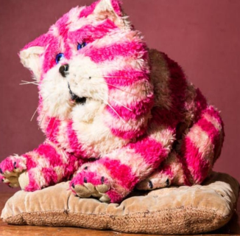
Ask all the members of your family about their favourite childhood toy. Write a sentence about what it is and why it was special. Draw pictures to go with it. | Visit Playopolis- the board game café in Rochester. Play a game you have never heard of before. Take some photos to show the class.   | Try out some sewing or fabric art and make a sock puppet.  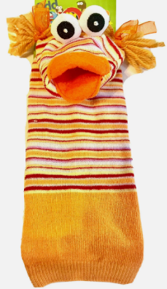 | Or any other project idea you have relating to modern toys or toys from the past.

