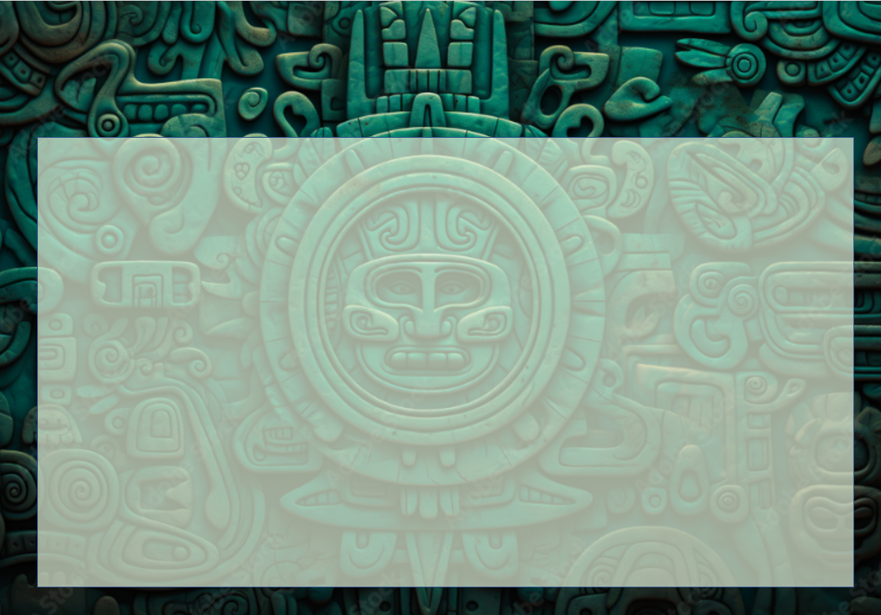
Year 6- Explorers- Holiday Homework Activities
Here are some optional homework activities to give you a head start on your learning. Bring the finished product in or share some photos with us. Merits will be awarded to all students who put effort into their project.

The ancient Maya introduced chocolate to the world! Prepare a traditional, spiced Mayan hot chocolate. Find a recipe online. Take pictures of your creation and write a short review of your experience. | Research the ancient Mesoamerican ballgame Pok-a-Tok. Write a set of instructions so you can teach the class to play it.  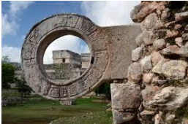 | Write a creative, diary-style entry from the perspective of an explorer who is lost in the Maya Forest. Describe what they can smell, the humidity they feel, and the dense sounds of the insects and birds.  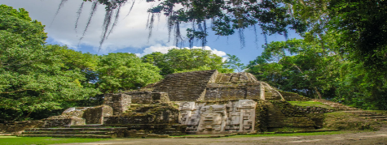 | Make your own model of Chichen Itza using recycled materials. Write some facts around it.  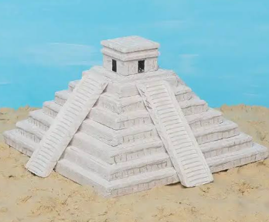
Find out about the flora and fauna in the Maya Forest and make an alphabetical list with illustrations.  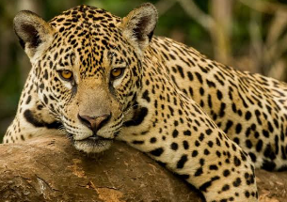 | 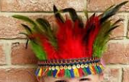  Design a colourful Mayan headdress using cardboard, construction paper, and bright feathers. | Make a poster showing the dangers facing the Maya Forest and what we could do to help save it.  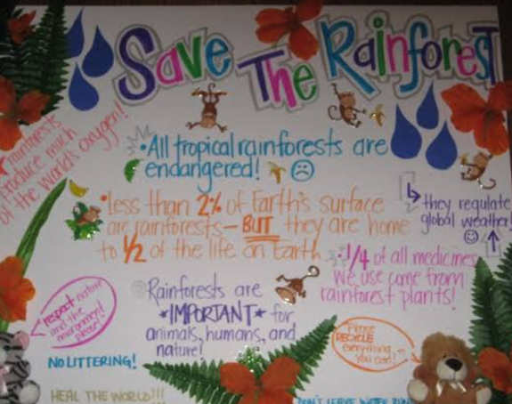 | Or any other project idea you have relating to the Mayan civilisation

