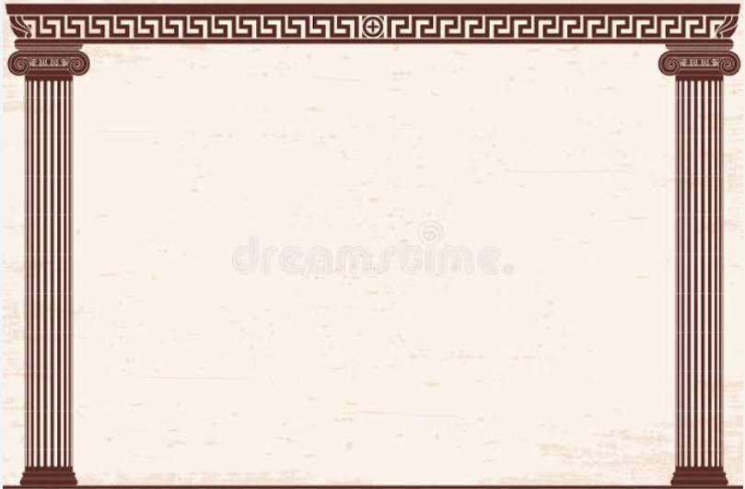
Year 5- Meet the Greeks- Holiday Homework Activities
Here are some optional homework activities to give you a head start on your learning. Bring the finished product in or share some photos with us. Merits will be awarded to all students who put effort into their project.

Create a picture of an imaginary Greek God or mythological creature. Make sure your poster is eye-catching and full of facts and information. Try to think of a symbol for your God. |   Interview somebody that has been to Greece. Write down what you found out or do a video interview. | Visit the British Museum in London. It has the biggest collection of Ancient Greek artefacts outside of Greece. Draw some pictures to show the class.  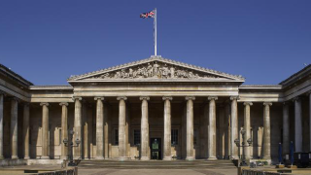 | Recreate the Parthenon using Lego, lolly sticks, or cardboard, or build a 3D model of an Ancient Greek windmill.  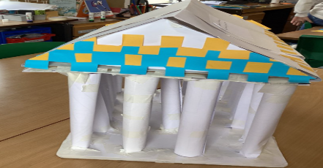
Turn a Greek myth—like Theseus and the Minotaur, or the myth of Icarus—into a drawn comic strip with speech bubbles.  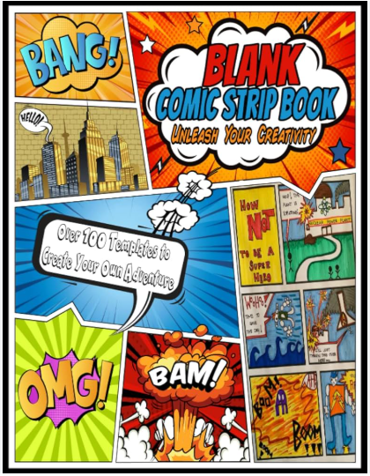 | Taste Greek food at a Greek restaurant. Or cook a traditional Greek meal (like moussaka, tzatziki, or baklava) and write up the recipe along with a photo of your creation.  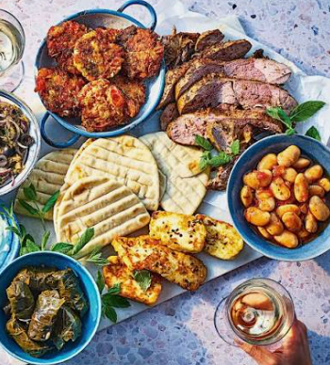 | Make an Ancient Greek theatre mask. Write your own Greek tragedy play and act it out wearing the mask.  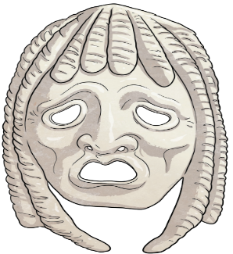 | Make a collage using pictures from  holiday brochures or the internet  showing ancient buildings and  interesting place to visit in modern Greece.
Or any other project idea you have relating to the Ancient Greeks.

