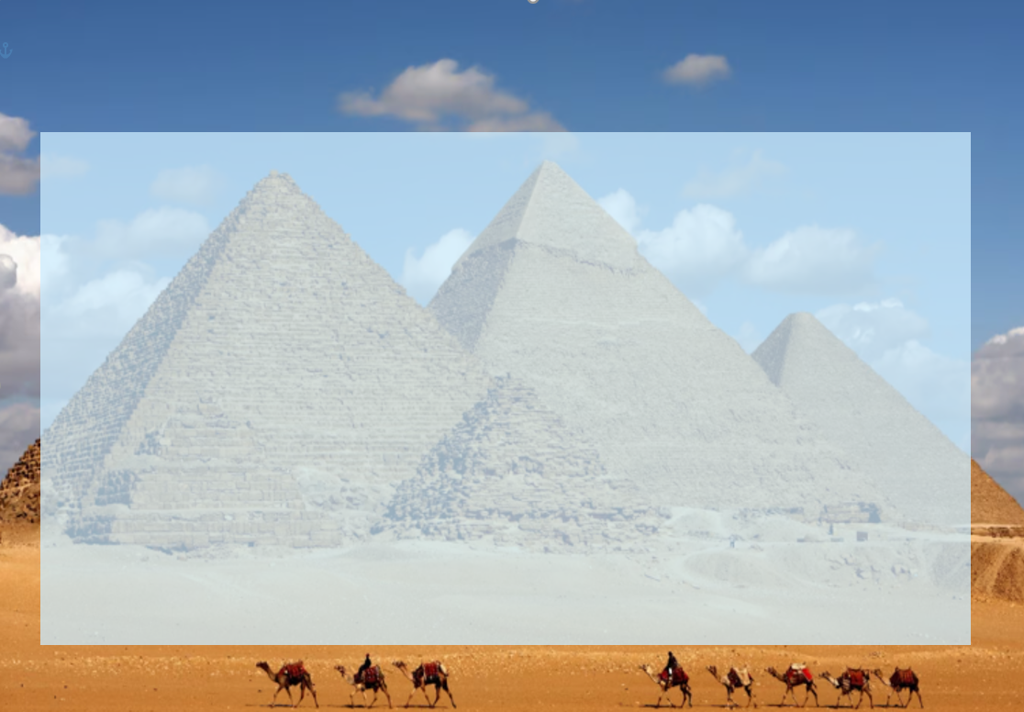
Year 4- Tomb Raiders- Holiday Homework Activities
Here are some optional homework activities to give you a head start on your learning. Bring the finished product in or share some photos with us. Merits will be awarded to all students who put effort into their project.

Write a sentence in Ancient Egyptian hieroglyphics.  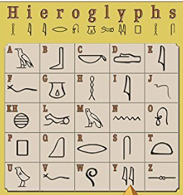 |   Interview somebody that has been to Egypt. Write down what you found out or do a video interview. | Visit the British Museum in London. Find out all about the Rosetta Stone. Draw some pictures to show the class.  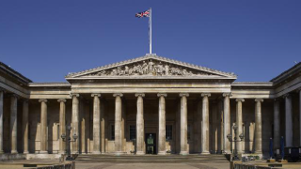 | Make a model of a pyramid and include some pyramid facts.  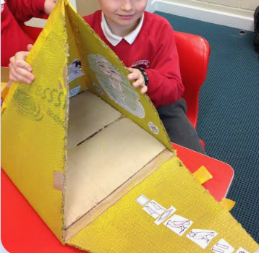
https://www.youtube.com/watch?v=gDOSWLZJP60  Take a virtual tour of Ancient Egypt. Write a story, poem or diary entry inspired by what you see. | 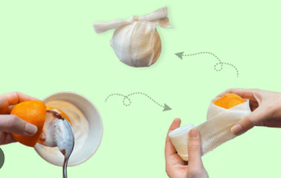  Practise your mummification skills on an orange. You can find the instructions on the internet. You need a grown up to help you with this challenge. | 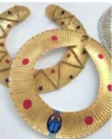  Make an Ancient Egyptian collar. Paint it gold and decorate it with Egyptian patterns. | Any other project idea you have relating to the Ancient Egyptians.

