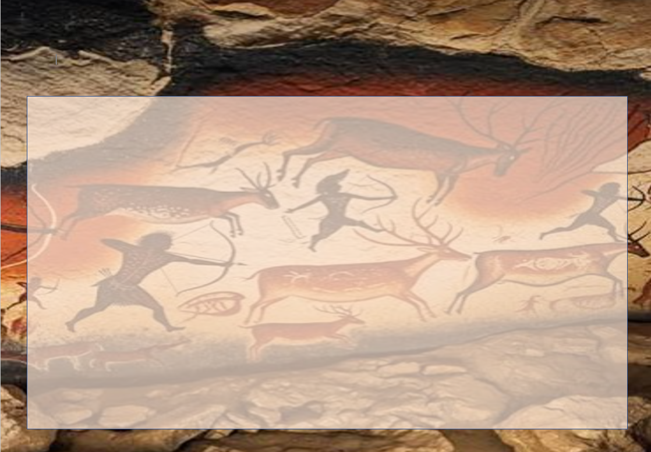
Year 3- Time Travellers- Holiday Homework Activities
Here are some optional homework activities to give you a head start on your learning. Bring the finished product in or share some photos with us. Merits will be awarded to all students who put effort into their project.

Write a story about being transported back in time to the Stone Age, Iron Age or Bronze Age. How did you get there? What happened to you there? What did you see? How did you get back? | 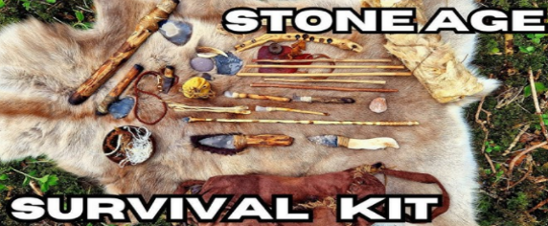  Create a leaflet for ‘How to survive the Stone Age.’ Imagine you are transported back to the Stone Age and need a guide to help you survive. What would the guide say? What tips would it have? | Visit the British Museum or the museum of London. Can you spot any Stone Age, Bronze Age or Iron Age artefacts? Draw some pictures to show the class.  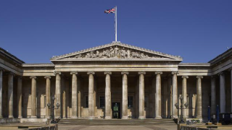 | Make your own model of Stonehenge using playdough, building bricks or boxes. Write some facts around it.  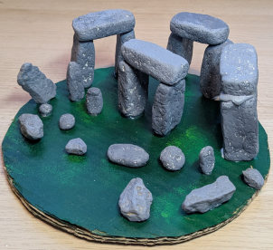
Cave Art: What pictures did Stone Age people paint? What did they use to paint with?  Paint a scene using "natural" materials (crushed berries, coffee, or mud) to tell a story about a mammoth hunt. Look at example cave paintings on the internet. | Find out about Stone Age animals and make an alphabetical list with illustrations.  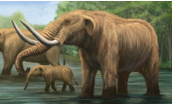 | Create a menu for a Stone Age restaurant. Think carefully about  what food and drink would be on offer.  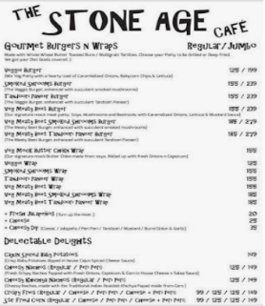 | Or any other project idea you have relating to the Stone Age, Iron Age or Bronze Age.

