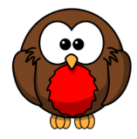
Welcome to Robins Class Newsletter Term 6 – June 2026
Dear Parents,
Welcome back, we hope you have all enjoyed a great half term and are now well rested and ready for the term ahead.
Reading
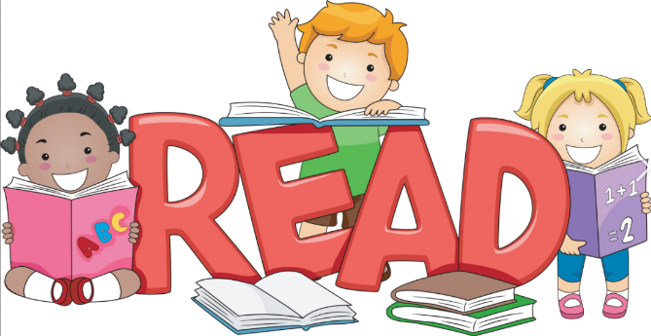
Your child’s reading book will continue to be changed twice a week on a Monday and Thursday. Please can you sign your child’s reading record or write a short comment. You child will continue to take home two books on these days. One book is a phonic book for your child to read to you. The second book is a storybook for you to read to them. Your child will only be able to get a new storybook when they have returned the previous one. In addition to this, your child will also continue to take home a RWI book that they have been reading in their RWI lesson. Please can these be returned to school in their plastic wallet to be changed on a Thursday.
Spelling
Last term, the children worked exceptionally hard on their spellings. It has helped them enormously in their independent writing. Below are the spelling for this term.
Test date | Spellings
Friday 12th June 2026 | Dogs  Cats  Thanks  Boys  Girls
Friday 19th June 2026 | Singing  Going  Talking  Cooking  Climbing
Friday 26th June 2026 | Jumped  Looked  Worked  Watched  Helped
Friday 3rd July 2026 | Higher  Taller  Colder  Helper  Teacher
Friday 10th July 2026 | Brightest  Softest  Greatest  Fastest  Quickest
Friday 17th July 2026 | Rain  Wait  Train  Paid  afraid

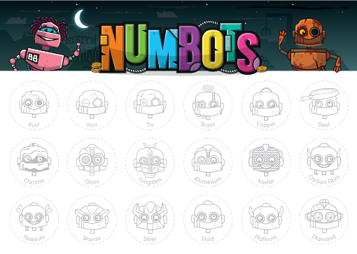
Numbots
It has been lovely to see that so many of you have been using Numbots. Please can your child continue to use the programme for at least 10 minutes per week again this term. Your child will continue to earn merits for each stage in the Story Mode (Rust to Diamond) they complete this term.

Maths homework
Last term the children worked exceptionally hard on their number bonds which has greatly helped their rapid recall of their number bonds within 10. Listed below are the number bonds we are going to be practising this term and an example of the questions your child will be asked.
Test date | Number bonds
Friday 12th June 2026 | Addition and subtraction facts for 8  4 + __ = 8  2 + __ = 8  7 + __ = 8  5 + __ = 8  1 + __ = 8  8 + __ = 8  6 + __ = 8  3 + __ = 8  0 + __ = 8  8 - __ = 3  8 - __ = 6  8 - __ = 4  8 - __ = 7  8 - __ = 0  8 - __ = 1  8 - __ = 8  8 - __ = 5  8 - __ = 2
Friday 19th June 2026 | Addition facts for 9  2 + __ = 9  4 + __ = 9  5 + __ = 9  1 + __ = 9  9 + __ = 9  3 + __ = 9  0 + __ = 9  6 + __ = 9  8 + __ = 9  7 + __ = 9
Friday 26th June 2026 | Subtraction facts for 9  9 - __ = 1  9 - __ = 3  9 - __ = 6  9 - __ = 8  9 - __ = 4  9 - __ = 7  9 - __ = 2  9 - __ = 0  9 - __ = 9  9 - __ = 5
Friday 3rd July 2026 | Addition and subtraction facts for 9  2 + __ = 9  4 + __ = 9  5 + __ = 9  1 + __ = 9  9 + __ = 9  3 + __ = 9  0 + __ = 9  6 + __ = 9  8 + __ = 9  7 + __ = 9  9 - __ = 1  9 - __ = 3  9 - __ = 6  9 - __ = 8  9 - __ = 4  9 - __ = 7  9 - __ = 2  9 - __ = 0  9 - __ = 9  9 - __ = 5
Friday 10th July 2026 | Addition facts for 10  2 + __ = 10  7 + __ = 10  4 + __ = 10  6 + __ = 10  1 + __ = 10  10 + __ =10  8 + __ = 10  3 + __ = 10  5 + __ = 10  9 + __ = 10  0 + __ = 10
Friday 17th July 2026 | Subtraction facts for 10  10 - __ = 2  10 - __ = 4  10 - __ = 8  10 - __ = 1  10 - __ = 6  10 - __ = 10  10 - __ = 9  10 - __ = 5  10 - __ = 3  10 - __ = 7


Our Curriculum
This term we are continuing with our theme of ‘Journeys’. Please have a look on the school website for detailed information on what the children will be learning.
Homework
Well done everyone for last term’s homework, the children’s vehicles were fantastic. For homework this term, linked to our science topic, we would like you to make a model of a mini beast. There is no set date for this to be completed; your child can just bring it in to share with the class when they are ready.
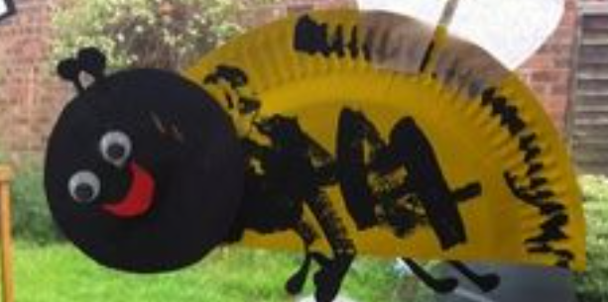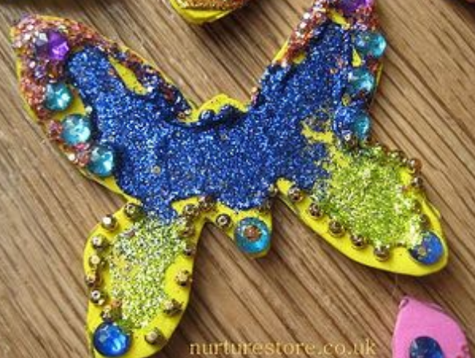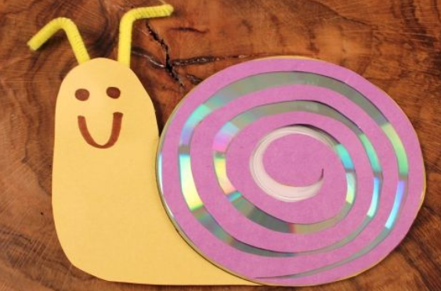
PE
P.E. will take place on Wednesday. Please can you ensure your child comes into school on this day wearing their correct PE kit. Please can you make sure that you take out your child’s earring on this day and that long hair is tied back.
Jumpers, water bottles, snack pots, sunhats and rain jackets.
Please can we ask you to make sure your child’s belongings are named as it makes it easier for us to return it to the correct person when it is lost.
Now the weather is getting warmer please can you make sure that your child has a named sun hat. As the weather is also a little unpredictable it would be helpful for year child to also have a waterproof jacket in their bag. As playtime is only ten minutes, please apply your child’s sun cream before arriving at school and have more in their bag, which they can reapply independently when needed.
If you have any questions please don’t hesitate to contact myself via the school office.
Thank you for your support.

Miss Lopes and Miss Harmon

