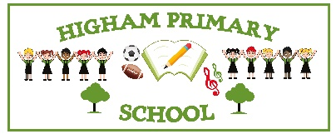
Rabbits Spellings Term 4

New spellings will be sent home each Tuesday to be practised during the week at home and tested the following Monday – See dates below.
Pupils also have a Spelling Shed account (login details are in their Reading Record Book), that gives them access to the online games which will support them in learning the weekly spellings. We would like children to spend at least 10 minutes per week playing these games as it will really help strengthen their recall.
In the spelling test we may also include other words with the same spelling pattern to see if they can apply the rule, spellings from previous weeks as well as the Year 2 Common Exception words that we will also have been practising in school. (See next page)
Please note there will be an additional spelling test at the start of term 5 that will be a selection of the words learnt from term 4.

To be tested on | Objective | Words
Monday 23rd February | Step 18: Challenge Words | every, everybody, even, great, break, steak, pretty, beautiful, after, fast
Monday 2nd March | Step 19: Words where ‘-er’, ‘-est’ and ‘-ed’ is added to words ending in ‘e’ | nicer, writer, baker, looser, safer, simpler, hoped, loved, largest, closest
Monday 9th March | Step 20: Words where ‘-ing’ is added single syllable words | patting, humming, dropping, running, hopping, clapping, sitting, flipping, wrapping, slipping
Monday 16th March | Step 21: Words where ‘-ed’ is added to single syllable words | patted, hummed, dropped, clapped, clipped, wrapped, napped, ripped, drummed, dragged
Monday 23rd March | Step 22: Words where ‘a’ makes an /or/ sound | all, ball, walk, call, talk, always, fall, small, also, bald
Monday 30th March | Step 23: Words where ‘o’ makes an /u/ sound | other, mother, brother, nothing, cover, money, some, dozen, wonder, done
Monday 20th April | Step 24: Challenge Words | last, past, father, class, grass, pass, plant, path, bath, rather

Year 2 Common exception words (To be learnt over the course of the whole school year)



