12/2/26
Dear Parents,
This year we will be celebrating World Book Day on Friday 6th March 2026.
Please see below for some of the exciting activities that will be taking place:
Read Together Morning
We will be hosting “A Read Together Morning” on Friday 6th March at 9.00 am. We would love you to come and share a book with your child, or a small group of children, and a biscuit. You may wish to bring in your favourite children’s book, or the children can choose one for you to read to them from our book corners. We will re-open the gate at 9.00am. We will kindly ask you to leave at 9:30am in order for lessons to commence.
Competition – Decorate a paper plate competition – All entries in by Wednesday 4th March 2026
Competition to “decorate a paper plate”. At the beginning of next term, every child will be given a paper plate to take home and decorate following the theme of a book. There will be a prize for the most imaginative and creative plates for each class. We will use the entries to update our display in the library. Please see below for some ideas.
The closing date for entries will be Wednesday 4th March with winners announced during assembly on Friday.
Dress-up day – Friday 6th March – World Book Day
Please can children come to school dressed as their favourite book character. It would be fantastic if they could also bring in the accompanying book to share as well! Please note it is not an expectation for parents to buy a costume and some of the best costume are often home-made! Children may wear face paint but please no hair dye!
We hope the children will enjoy the day and that it will help to highlight the pleasures of reading.
Yours sincerely

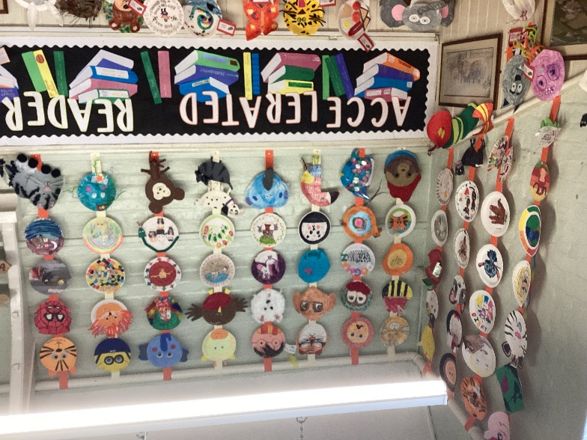
Mrs V Levy and Miss E Davey


